**Project 1 – Sunrise Alarm**

This project will allow you to build an alarm clock that will activate when the sun rises, using the Photoresistor to measure the light levels, and the buzzer and the two LEDs to try and wake you up!

**You will need:**

* Raspberry Pi (fully set up and connected to the internet)
* Breadboard
* Photoresistor
* 330nF Ceramic (bidirectional) Capacitor
* 2x Red LEDs
* Buzzer
* 2x 10kΩ Resistors
* 2x 470Ω Resistors
* 6x Male to Female Jumper Wires
* 3 x Male to Male Jumper Wires

**Instructions:**

1. Ensuring that the Raspberry Pi is turned off, make the circuit and connect it to the Raspberry Pi as shown in the diagram.

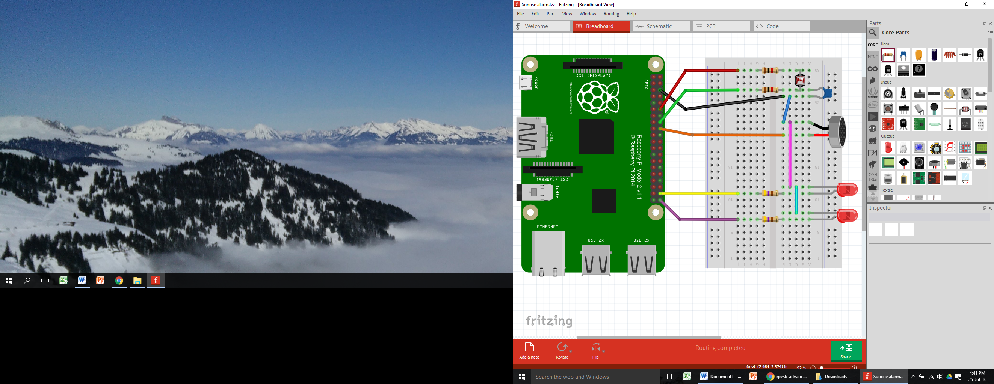

**1kΩ**

**470Ω**

1. Turn on the Raspberry Pi and install the software using the following command in LXTerminal:

$ git clone <https://github.com/henrybudden/rpesk-advanced>

1. Once the software has downloaded, change directory with the command:

$ cd rpesk-advanced

1. Finally, run the code using the command:

$ sudo python 01_sunrise_alarm.py